IRIS FLOWER CLASSIFICATION:

EVALUATION OF IRIS FLOWER:

COMPUTER VISION:

NATURAL LANGUAGE PROCESSING :

OUTPUT

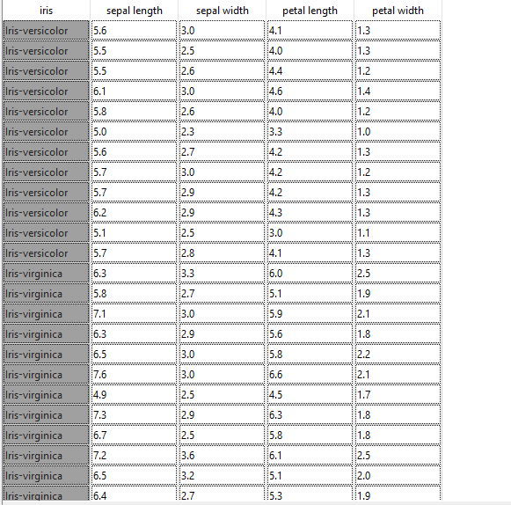

IRIS FLOWER CLASSIFICATION:

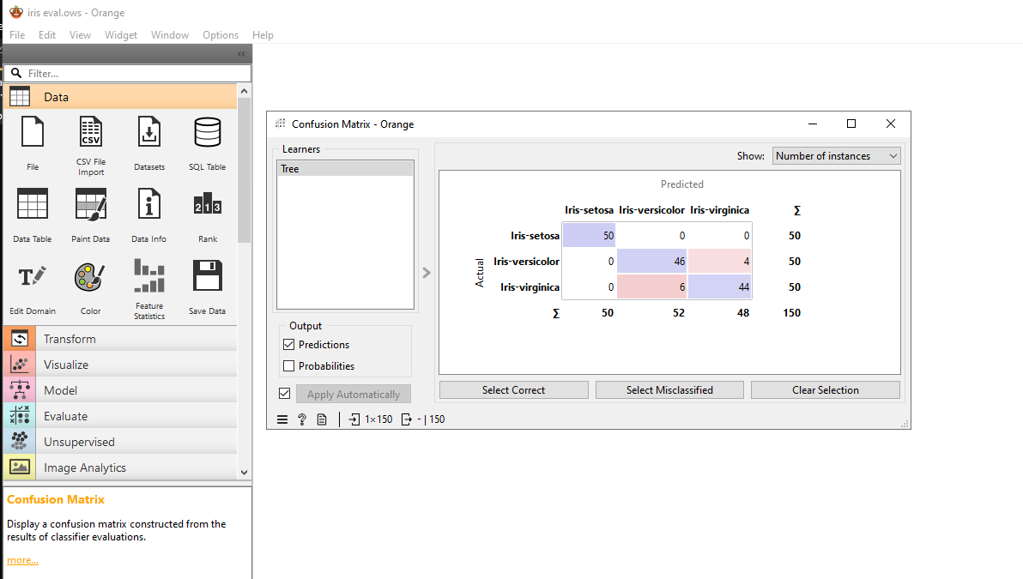

EVALUATION

COMPUTER VISION :

BEFORE:

AFTER:  
NATURAL LANGUAGE PROCESSING :